Torrens lake metrological data analysis:

Data columns information:

'TS': 'TIMESTAMP',

'V': 'batt_volts',

'd': 'modem_resets',

'C': 'WaterTemp',

'uS/cm': 'Electrical_Conductivity',

'%': 'O2_percent',

'mg/L': 'O2_mg',

'C.1': 'TAC_temp(0.1 m)',

'C.2': 'TAC_temp(0.2 m)',

'C.3': 'TAC_temp(0.3 m)',

'C.4': 'TAC_temp(0.4 m)',

'C.5': 'TAC_temp(0.5 m)',

'C.6': 'TAC_temp(0.6 m)',

'd.1': 'TAC_errorsensors',

'uS/cm.1': 'Sp_Cond'

On exploration, it really excite me with the level of oxygen over time. For adealide zoo lake

Visualizing temperature, electrical conductivity of water, and oxygen level

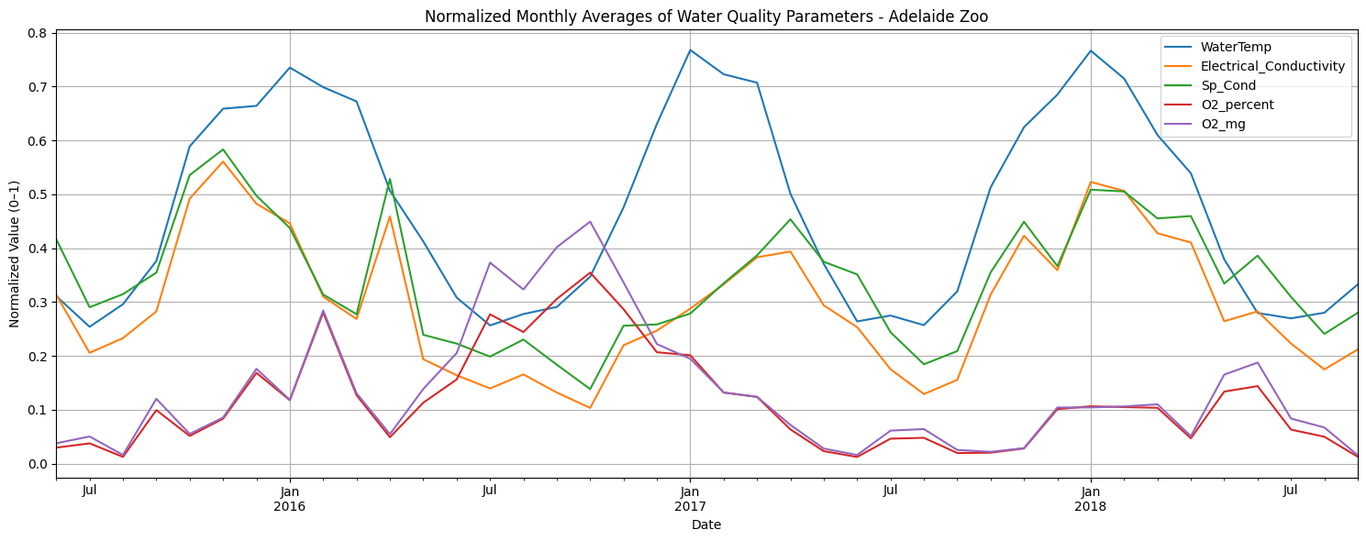

p-test shows the significance of temperature with oxygen and conductivity as well when data was not averaged and recorded in every 15min. That shows good significance with factors temperature, oxygen level and conductivity.

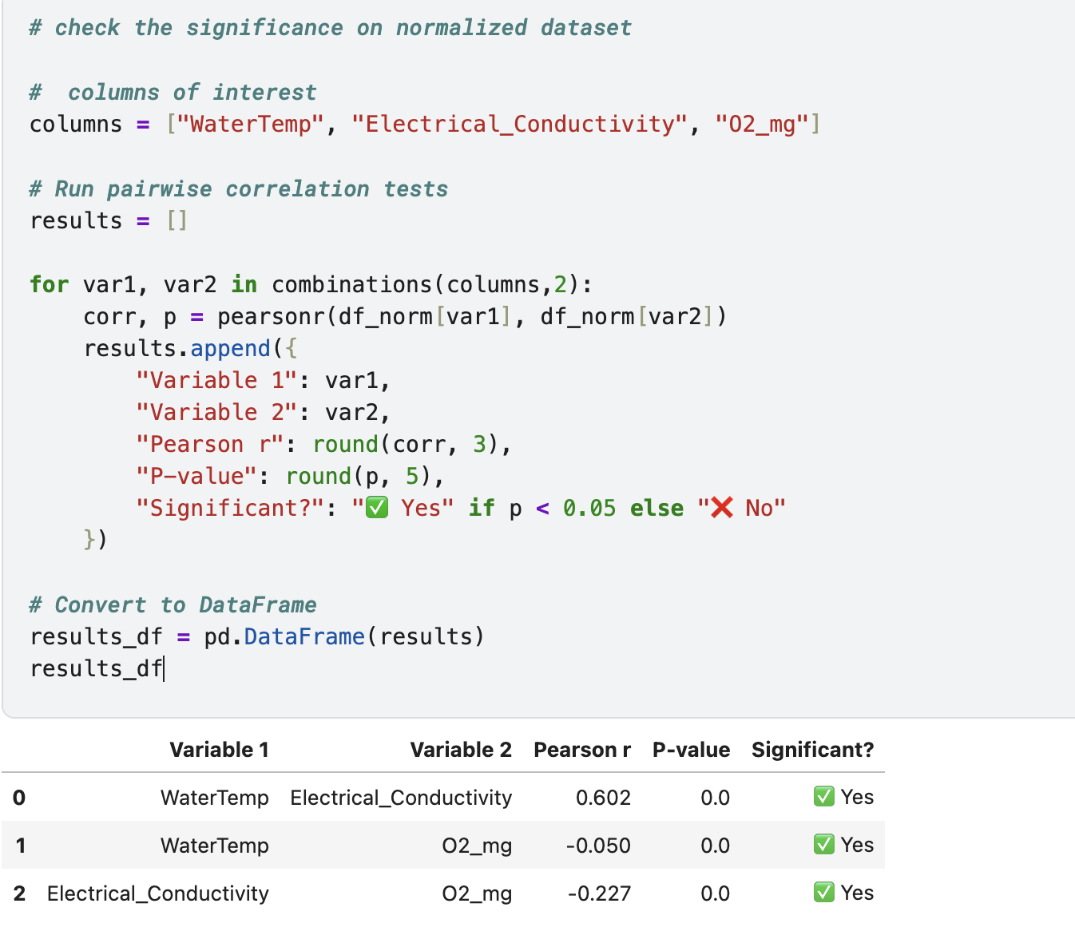

Averaging the recorded values for montly average results different, which shows statistically insignificance between oxygen level and temperature. Which suggest there’s insufficient evidence to conclude a relationship exist between those two variables.

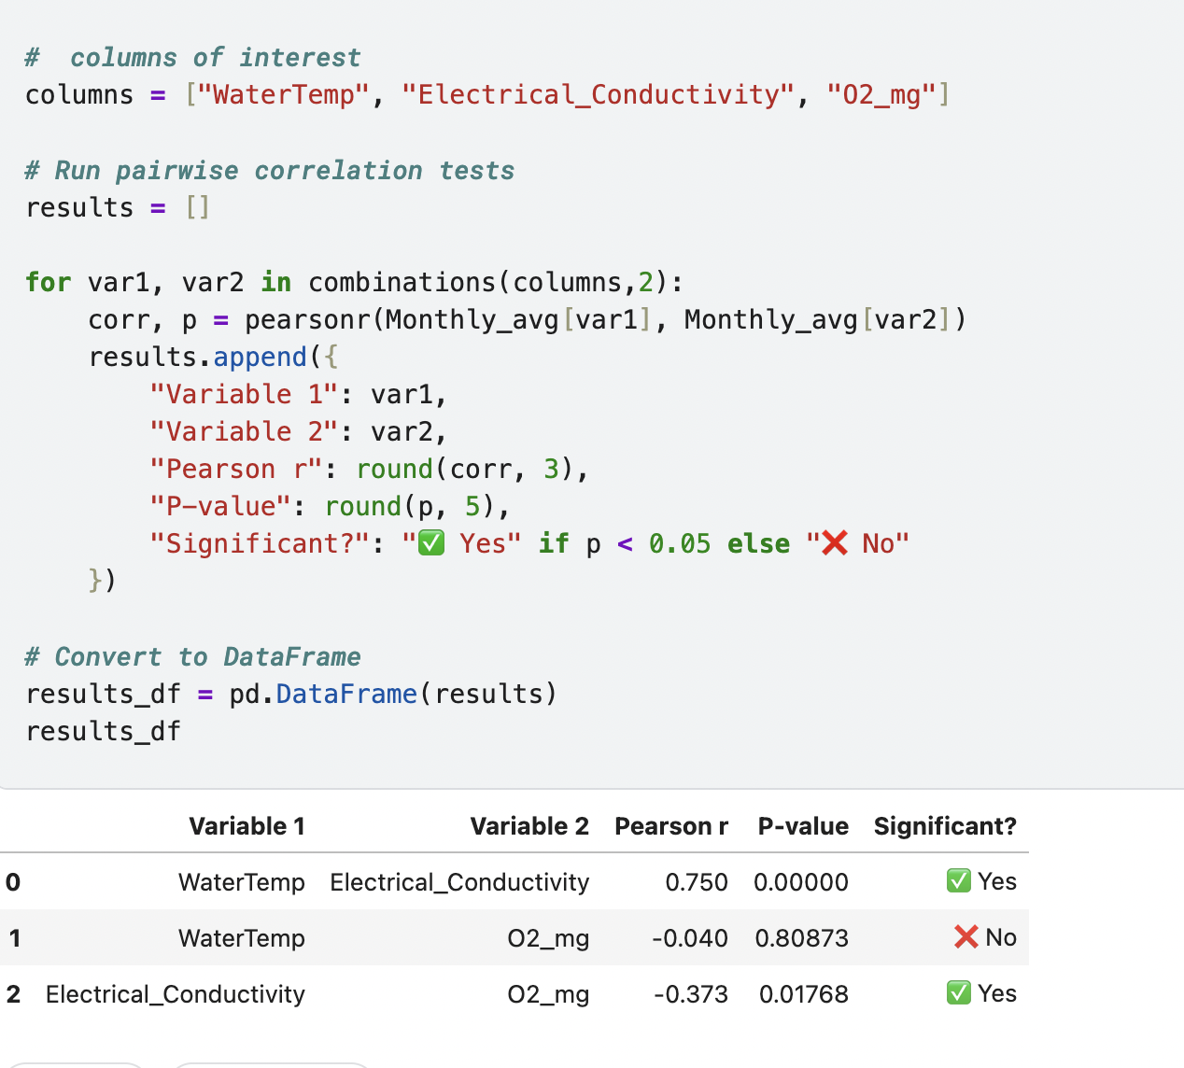

later on, while visualizing the oxygen level over time

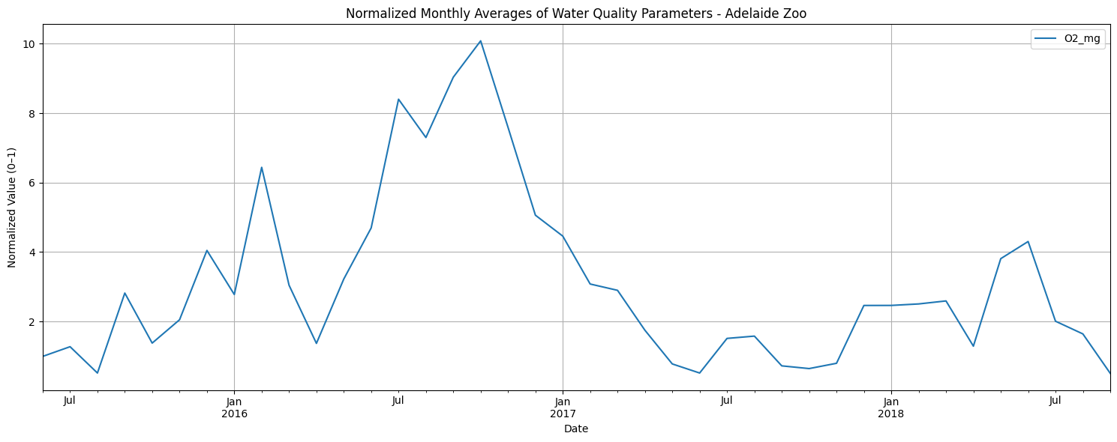

The trend clearly shows after 2017, level of oxygen mg/L had started drop to unsuitable for marine life range, and could not get recover and keep dropping. Finding the reason behind this damage and solutions to bring the lake into life is necessary.

And this decline in oxygen level in water is unsuitable for fish and other aquatic life (according to Department of Climate Change, Energy, the Environment and Water, Australia). According to "Fondriest Environmenta" Bottom feeders, crabs, oysters and worms need minimal amounts of oxygen (1-6 mg/L), while shallow water fish need higher levels (4-15 mg/L)⁵.